**Git Implementation**

1. **Git – Offline Mode**

* Git Server
* Git Client

1. **GitHub – Online Mode**

Repository Type -

* Public – Free (For Open Source Projects)
* Private – Paid

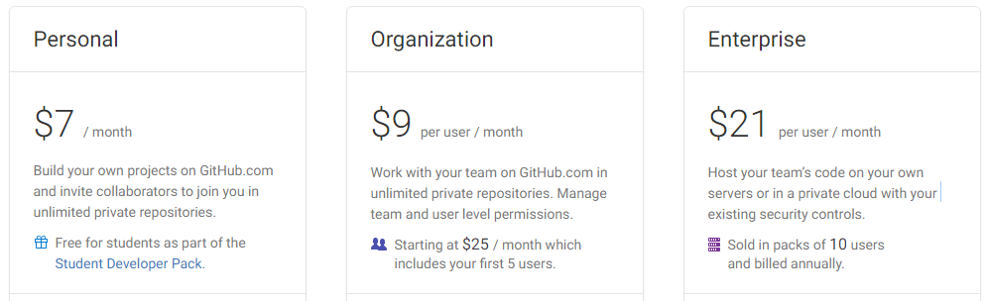

GitHub Extension for Visual Studio -

<https://visualstudio.github.com/>

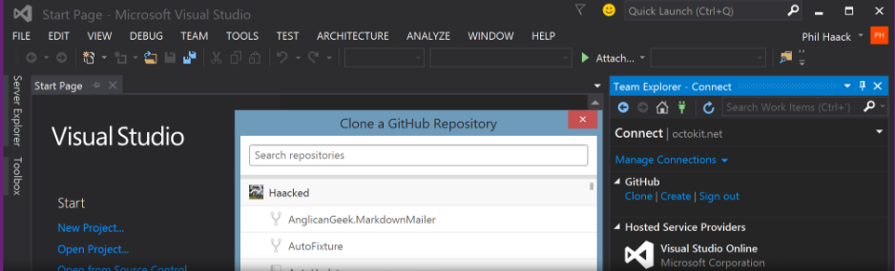

**Connect to GitHub -**

Once you install the extension, you can log into your GitHub.com or GitHub Enterprise account in Visual Studio with full support for two-factor authentication. There is no need to use personal API tokens.

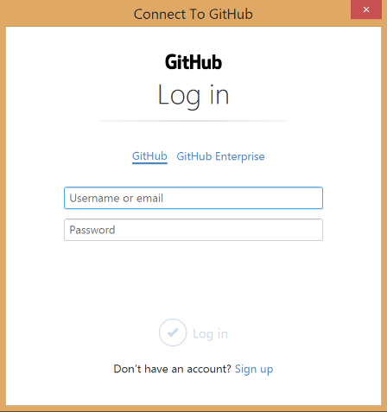

**Cloning Repositories –**

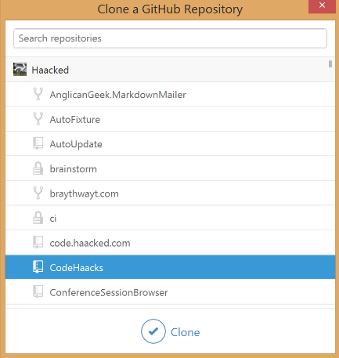

**Publish Local Project to GitHub –**

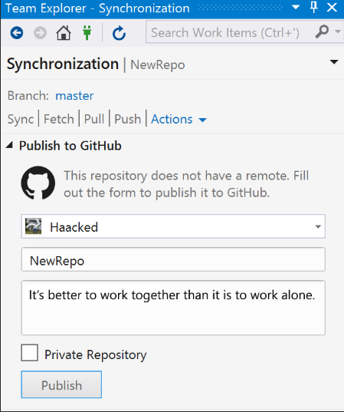

Release definitions in Microsoft Release Management

## **Create a release definition**

Open the **Build & Release** hub menu and choose **Releases**.

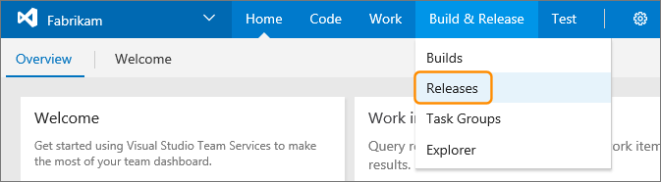

If you have just created a new account, you see a welcome message. Choose **New definition**.



If you have already created your account, choose the plus icon at the top left of the main window and select **Create release definition**.

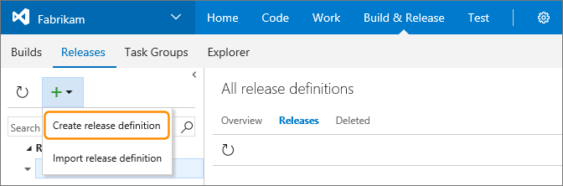

This opens a wizard that helps you set the basic features of your new release definition. In the first page, you can select one of the pre-defined templates, or start with an empty release definition.

## **Troubleshooting**

### **I don't see the Publish button in the status bar.**

A: The **Publish** link in the status bar ( Publish to Git from the Visual Studio Status bar ) was added in Visual Studio 2015 Update 2 and will only appear when you have Git as your source control provider. If your code is already in a Git repo, you won't see the **Publish** button in the status bar, but the information from your local repo instead.

If you are in a previous version of Visual Studio, create a local Git repo for your project by selecting the **Create new Git repository** option in the **New Project** window when you create a new project.

You can create a local Git repo for an existing solution by right-clicking your project in the Solution Explorer and selecting **Add Solution to Source Control**.